**Assignment 1**

**Question 1:** Find the most cost-effective path to reach from start state A to final state J using the following Algorithms. In the given graph. The values written on top of node are the heuristic values while those written on the edges are the actual cost.

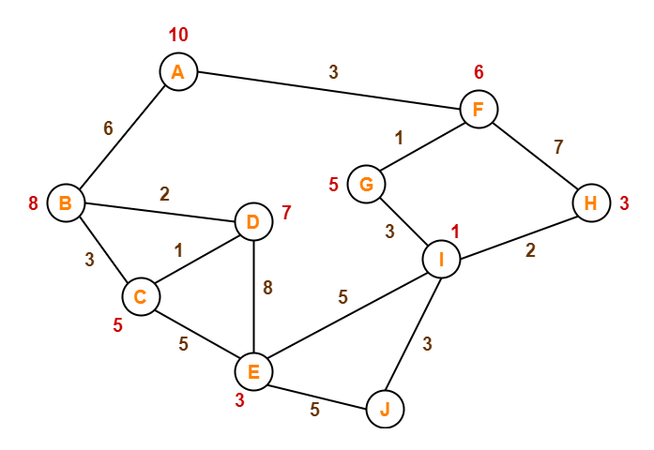

1. UCS
2. Greedy (best first search)
3. A *
4. Iterative deepening A*

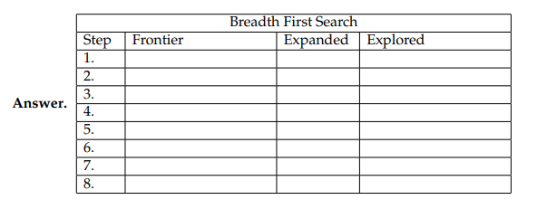

**Question 2:** Do complexity (space and time) evaluation of all the search algorithms we have done so far in this course.